Williamson’s Sapsucker

Area of Occupancy and

Habitat Model Updates 2021

Prepared by:
Les Gyug, Okanagan Wildlife Consulting, West Kelowna, BC

Prepared for:
B.C. Conservation Foundation

March 15, 2021

TABLE OF CONTENTS
Introduction 2
WISA Area of Occupancy Revisions 2
WISA Habitat Modeling Update 7
Data Products 12
References 12
Appendix 1. Williamson's Sapsucker Habitat Modeling Methods 14

List of Maps

Map 1. West WISA Areas of Occupancy revisions 2021 4
Map 2. Okanagan-Boundary WISA Areas of Occupancy revisions 2021 5
Map 3. East Kootenay WISA Areas of Occupancy revision 2021 6
Map 4. West Region 2018 nest and foraging habitat suitability 10
Map 5. Williamson's Sapsucker 2018-2021 habitat suitability model updates Okanagan-Boundary region 11

Introduction
Williamson's Sapsucker is a migratory woodpecker assessed as Endangered (COSEWIC 2005, 2017) and is on Schedule 1 of the Species at Risk Act. This current project was completed by Les Gyug of Okanagan Wildlife Consulting on contract to the B.C. Conservation Foundation with funding from the Ministry of Forests, Lands, Natural Resource Operations and Rural Development, Penticton, BC.
The purpose of this particular phase of the Williamson's Sapsucker project was to provide a common basis for assessing habitat suitability in Wildlife Habitat areas, by:
- updating the Endangered Williamson’s Sapsucker (WISA) Area of Occupancy (AO), boundaries, which have not been updated since 2008, and
- completing the 2018 habitat suitability model for the Boundary that had begun in 2018 for the West and Okanagan-Boundary regions.

WISA Area of Occupancy Revisions
The AO was originally estimated in 2005 as 1016 km² for Okanagan-Boundary and West regions but its size was not estimated for East Kootenay because only four nest sites were known (COSEWIC 2005). The boundaries of the AO were revised considerably in 2007 based on new inventory information from 2005-2007, and then refined slightly based on 2008 and 2009 inventories. The 2009 AO was used as the project area for the 2008 habitat suitability modeling and mapping (completed in 2009 and 2010 for all three regions), and the designation of Critical Habitat under SARA. Considerable additional WISA inventory had been undertaken since 2008 with many WISA found in suitable habitat within 5 km of the 2008 AO, which were not considered cases of vagrancy. Gyug and St-Amand (2020) also revisited the rationale for the AO, adding bioclimatic modeling for B.C. and western North America (Wang et al. 2012, 2016), which was not available in 2008. This modeling, along with additional WISA detections outside the AO boundaries, indicated that the 2008 AO boundaries may have been drawn too narrowly and based on insufficient information, and that a revision was in order.
Area of occupancy is defined as the area within a taxon’s extent of occurrence, which are occupied, excluding cases of vagrancy. The measure reflects the fact that a taxon will not usually occur throughout the area of its extent of occurrence, which may contain unsuitable or unoccupied habitats. The size of the area of occupancy will be a function of the scale at which it is measured, and should be at a scale appropriate to relevant biological aspects of the taxon, the nature of threats and the available data (IUCN 2001). While the recommended AO scale is generally 2-km x 2-km cells, the recommended scale for Williamson’s Sapsucker, and for woodpeckers in general, is 5 km separation of habitats, i.e., gaps of >5 km would be considered separate locations (NatureServe Explorer 2021).
In the Okanagan-Boundary, there were 11 locations where new surveys found WISA within 5 km of the 2008 AO, and where extension of the AO was considered appropriate, i.e., these were not cases of vagrancy, but rather active nests or birds on possible breeding territories. These included additions near Naramata, Ellis Creek, the north side of Vaseux Creek, Anarchist Mt., Ed James Creek, Rock-Creek-Bridesville Rd, Westbridge Burn, two areas north of Highway 3 and west of Ingram Creek, an area at the head of Ingram Creek, and an area on the north side of Wallace Creek. A WISA was detected north of Grand Forks but 10 km from the existing AO by Richard Cannings, but because it could not be re-located on our surveys, that site was not included in the AO revision.
In addition, on Phoenix Mt, only one small area around active nests was included in the 2008 AO. However, WISA were found elsewhere on Phoenix Mt. in 2005, and again in 2012, indicating that the AO should be considerably expanded in that area. Total area added to the Okanagan-Boundary AO was 74.26 km² on Phoenix Mt. expanding it considerably to 78.73 km². Elsewhere, 59.99 km² were added to the AO. This brought the total Okanagan-Boundary revised 2021 AO area to 832.14 km² from 697.89 km². No areas were removed from the 2008 AO when updated to 2021.
In the East Kootenay, there was one active WISA nest found 600 m outside the AO about 7 km south of Cranbrook in 2011. The area near this nest and similar adjacent areas (6.778 km²) were included in the revised 2021 East Kootenay AO (now 857.945 km²).
In the West, an area of 16.67 km² on Iron Mountain was excluded from the AO because WISA had not been found there (59 call playback survey points) despite some apparently suitable habitat available, and the area was not within the 95% bioclimatic envelope as defined for WISA (see Gyug and St-Amand 2020). Added were four areas based on an active nest found (Coutlee Plateau southwest of Merritt), on WISA detected in three of the areas on at least some of the annual roadside CPB surveys (Coutlee Plateau, west side of Kane Valley, and Copper Mt Road south of Princeton), and three WISA found in one area north of Dodds Lake on the 2012 WISA inventories. Total area added was 14.38 km². The revised 2021 West AO was reduced from 742.46 km² in 2009 to 740.17 km² in 2021.

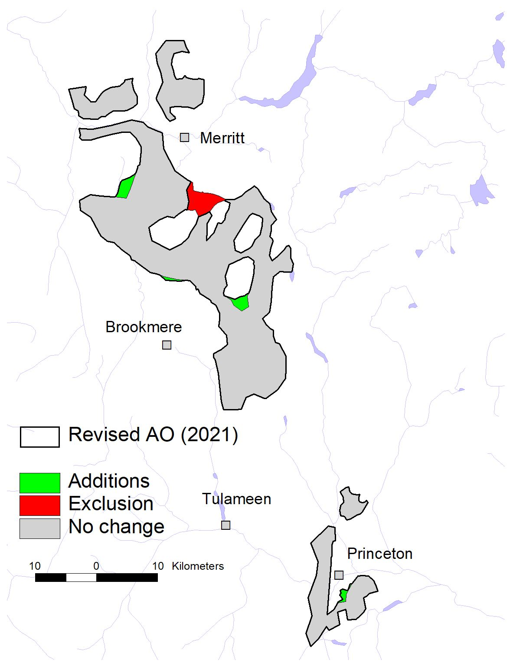
Map 1. West WISA Areas of Occupancy revisions 2021.

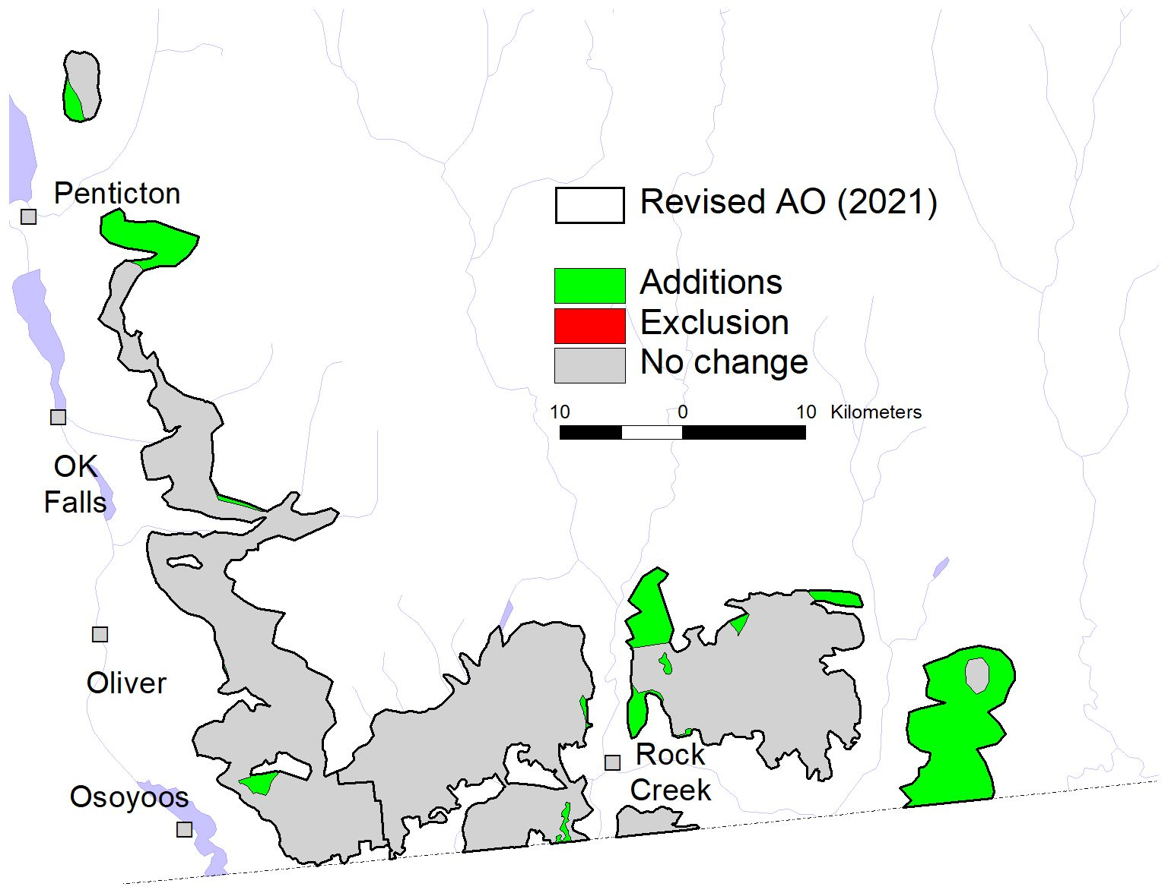
Map 2. Okanagan-Boundary WISA Areas of Occupancy revisions 2021.

Map 3. East Kootenay WISA Areas of Occupancy revision 2021.
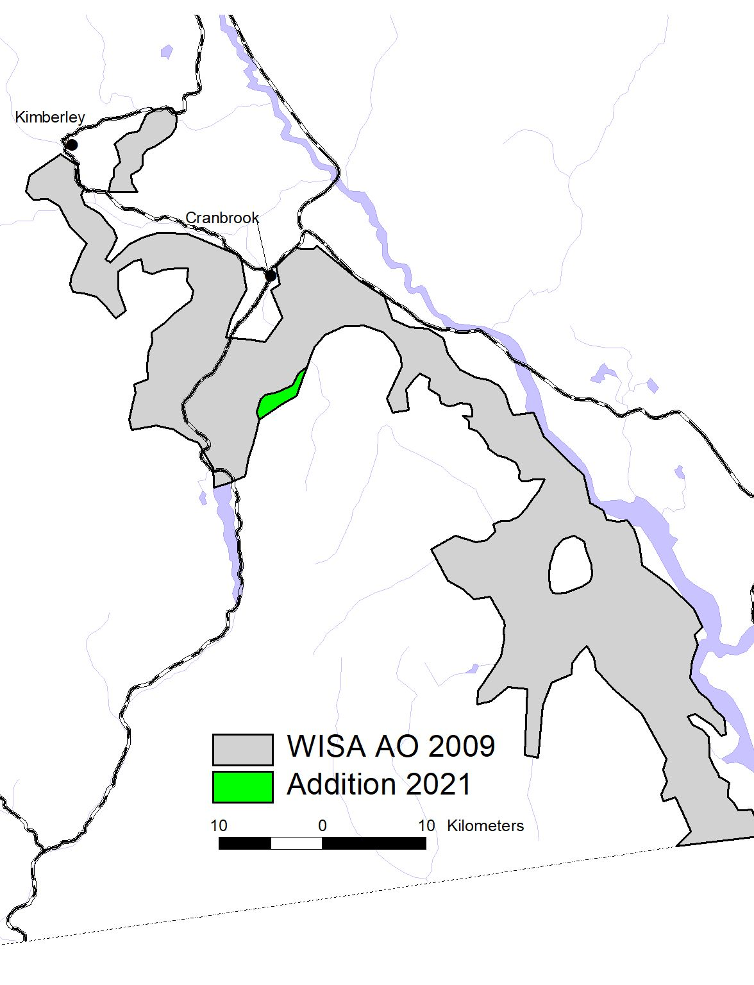

WISA Habitat Modeling Update
The 2008 habitat mapping (Gyug 2009, 2010a, 2010b) was updated in March 2018 for the West, Okanagan, and the Boundary, excepting the Phoenix Mt., and the TFL 8 block of the Boundary (and immediately adjacent crown and private lands) (Gyug 2018). While based on 2018 VRI, which is always about two years behind for recent harvesting or wildfires, the 2018 VRI was updated manually by inserting recent cutblocks and fire polygons to March 2018. As of 2021, the provincial VRI included Interfor’s TFL 8, so, in March 2021, the 2018 habitat suitability update was completed with the addition of the areas not updated in 2018, using the AO as revised in March 2021 (see previous section of this report).
Recent cutblocks and fires were not inserted manually into the March 2021 coverages, so, even while done in 2021, the habitat mapping is current to about 2018. Habitat mapping for the areas already completed in March 2018 were not revised to the new AO boundaries, so there will be a few small gaps in the habitat mapping. In 2020, a foraging model based on radio-telemetry data was added to the nesting model (Gyug and St-Amand 2020), which was also added to the new update done in March 2021.
The East Kootenay habitat mapping of 2010 (Gyug 2010c) has not been updated. Annual and other monitoring of that regional population has shown it to be too small (in the range of 20-40 pairs) to allow for model verification. With a population that small, there will always be apparently suitable habitat that will be unutilized.
Nominal Project Map Scale: 1:20,000 (accuracy typically ±20 m)
Map and Image Products Used:
In 2018, the base coverage was Vegetation Resource Inventory (VRI) geodatabase with projected date of January 1, 2016 downloaded from Data BC in February 2018 (https://data.gov.bc.ca/). In 2021, the base coverage was VRI with projected date of January 1, 2020, downloaded from Data BC in February 2021.
VRI was designed to be reliable at the regional scale, and required local interpretation to make it reliable for WISA habitat modeling at the polygon scale. In 2008 and 2018, considerable additional polygon-by-polygon interpretation was described in previous reports. No additional polygon-by-polygon interpretation was done in 2020 or 2021 except to verify conditions within the telemetry analysis. Further caveats about fine-scale interpretation of VRI are discussed within the modeling text.
Digital Elevation Models and Imagery products used in 2008-2020 are described in previous reports.
The methods of the modeling have been detailed in previous reports, particularly Gyug (2018) and Gyug and St-Amand (2020). Details are in Appendix 2 of this report, especially noting any refinements or changes since the previous reports.
Basic Model Assumptions
- The 6-class ratings scale of RISC (1999) were used to rate nesting and foraging habitat suitability (see details in Gyug and St-Amand 2020).
- These models only apply within the regionally contiguous Areas of Occupancy.
- The nest habitat model was derived from nest locations and is therefore a nest stand model, although WISA will only nest where foraging habitat is also suitable, so includes an element of foraging habitat as well.
- Foraging habitat was derived from analysis of the radio-telemetry observation data used by St-Amand (2017). However, the derived foraging model used tree density as the only factor (see Gyug and St-Amand 2020) because, although foraging suitability will rely on tree species, tree species were already considered in the nest habitat model. The foraging model was only to be applied sequentially after the nest habitat model had been applied.
- Foraging suitability will only decrease the nest habitat model rating based on insufficient foraging resources within distances typically traveled to suitable foraging habitat, and the amounts of suitable foraging habitat within typical breeding territories.
- The foraging model was applied based on VRI-estimated live stems >17.5-cm dbh/ha rather than field plots, which were not available for every VRI polygon in the telemetry study. VRI tended to overestimate density for stands with plot-derived >200 live stems/ha, and underestimate for stands with <150 live stems/ha (Gyug and St-Amand 2020). The VRI also tended to overestimate Quadratic Mean Diameter for stands where the plot-derived QMD was >35-cm dbh, and overestimate Basal Area where plot-derived BA was >12 m²/ha.
After application of the nest habitat and foraging models, which included the areas newly incorporated into the AO for the areas modeled in 2021, but not for the areas modeled in 2018, area by suitability classes were totaled for each region (Table 1). The nest habitat, foraging habitat, and combined habitat suitability model results are shown in Maps 4-6 for the West and Okanagan-Boundary regions.

Table 1. Summary of areas of WISA nesting habitat suitability model (2018-2021) and foraging habitat suitability model (2020) and the combined effect on habitat suitability.
Suitability Class | Okanagan-Boundary² |  |  |  | West²
Suitability Class | Nesting | Foraging³ | Combined |  | Nesting | Foraging³ | Combined
1 | 15.5 | 121.9 | 11.6 |  | - | 206.2 | -
2 | 40.8 | 286.3 | 30.4 |  | - | 218.7 | -
3 | 83.6 | 286.3 | 66.0 |  | 60.2 | 218.7 | 42.2
4 | 289.8 | 122.9 | 250.7 |  | 268.9 | 36.1 | 237.9
5 | 326.2 | 145.8 | 396.6 |  | 331.1 | 70.3 | 379.9
6 | 43.5 | 123.3 | 43.5 |  | 65.7 | 194.5 | 65.7
Totals¹ | 799.4 | 800.2 | 798.8 |  | 725.9 | 725.8 | 725.7
¹Totals of the models are not identical because of rounding, and because when VRI polygons were converted to grids, and then the pixels re-converted to polygons, the shapes were not identical.

²Suitability classes are only given for areas that have been mapped, which does not include a number of separate small additions to the AO in both regions in 2021. West numbers exclude the area excluded in the 2021 AO revision, but do not include the areas newly added.

³Moderately High (2) and Moderate (3) were not separated in the foraging model.
These models were only for current suitability, not capability, i.e., not for potential suitability. Almost any potentially forested polygon in the AO is capable of becoming suitable WISA nesting and/or foraging habitat if suitable nest trees can be developed from within the stand, and suitable-density foraging stands are available. A capability model would be based primarily on Site Index, slope, aspect and (lack of) potential for Cw. Mean Site Index for Class 1 nest suitability habitat was 17.0 (SD 2.0, minimum 14.0, n = 163 polygons), and for Classes 2-5, mean Site Index ranged from 13.5 to 15.0 (SD 2.6-3.4) with similar ranges for all suitability classes (except Null, which were non-forested and had no Site Index).

Map 4. West Region 2018 nest and foraging habitat suitability (see Gyug and St-Amand 2020). Blank spots within AO have not been updated with habitat mapping after 2021 AO revisions. The single area deleted is outline in grey.
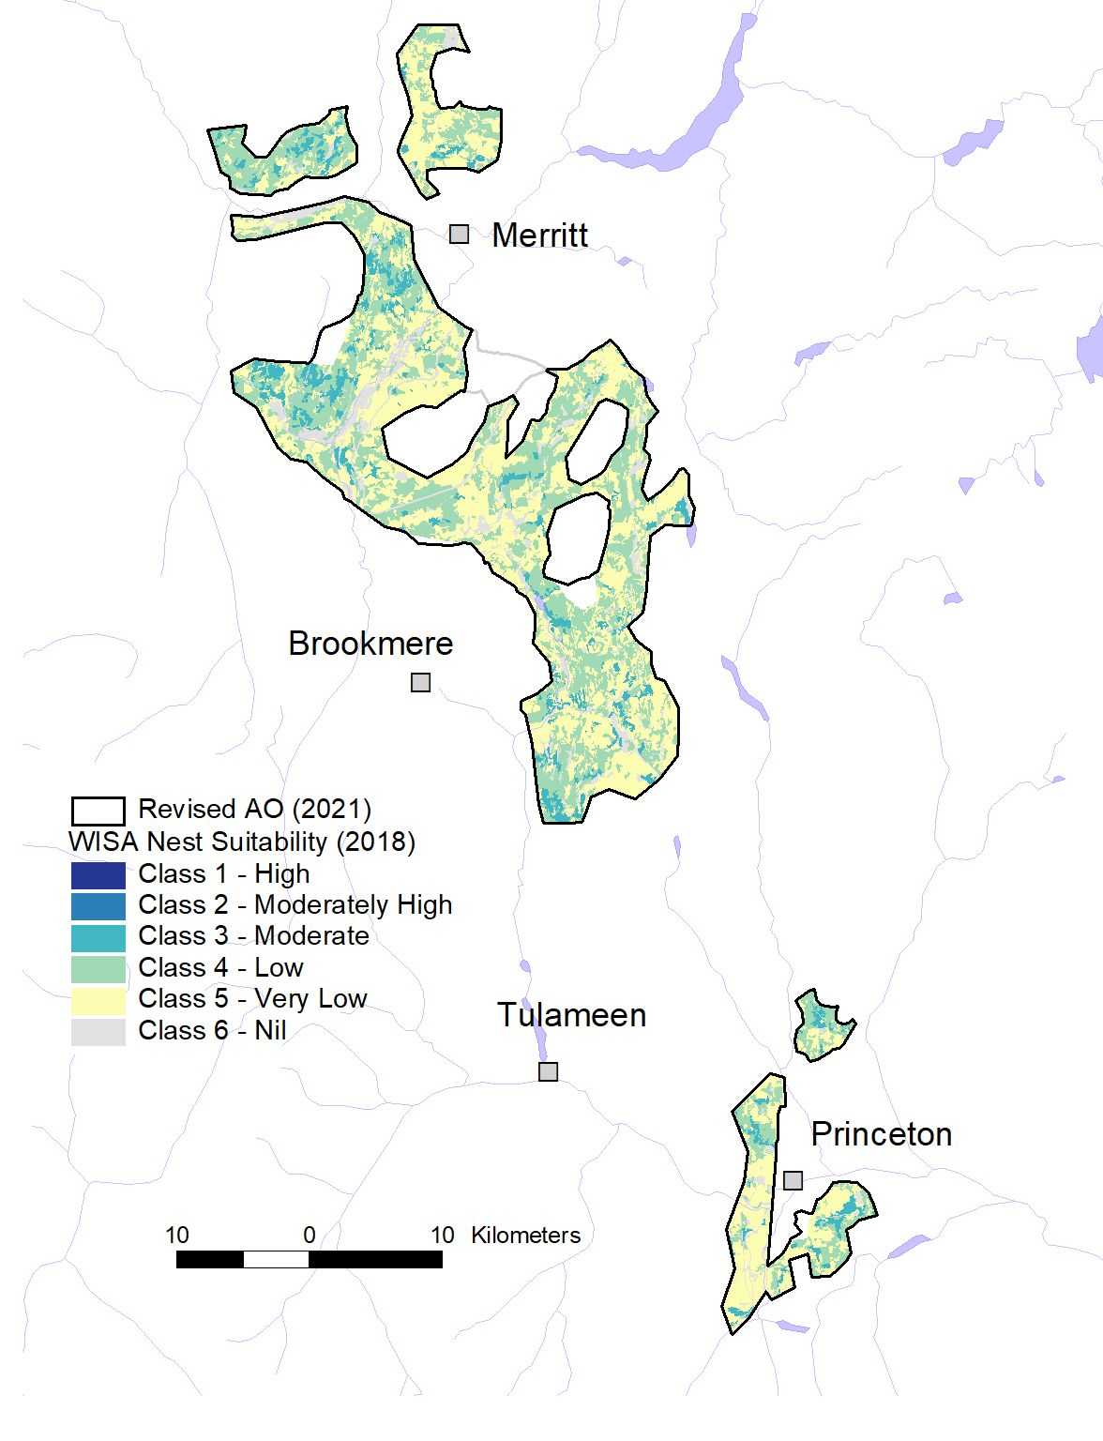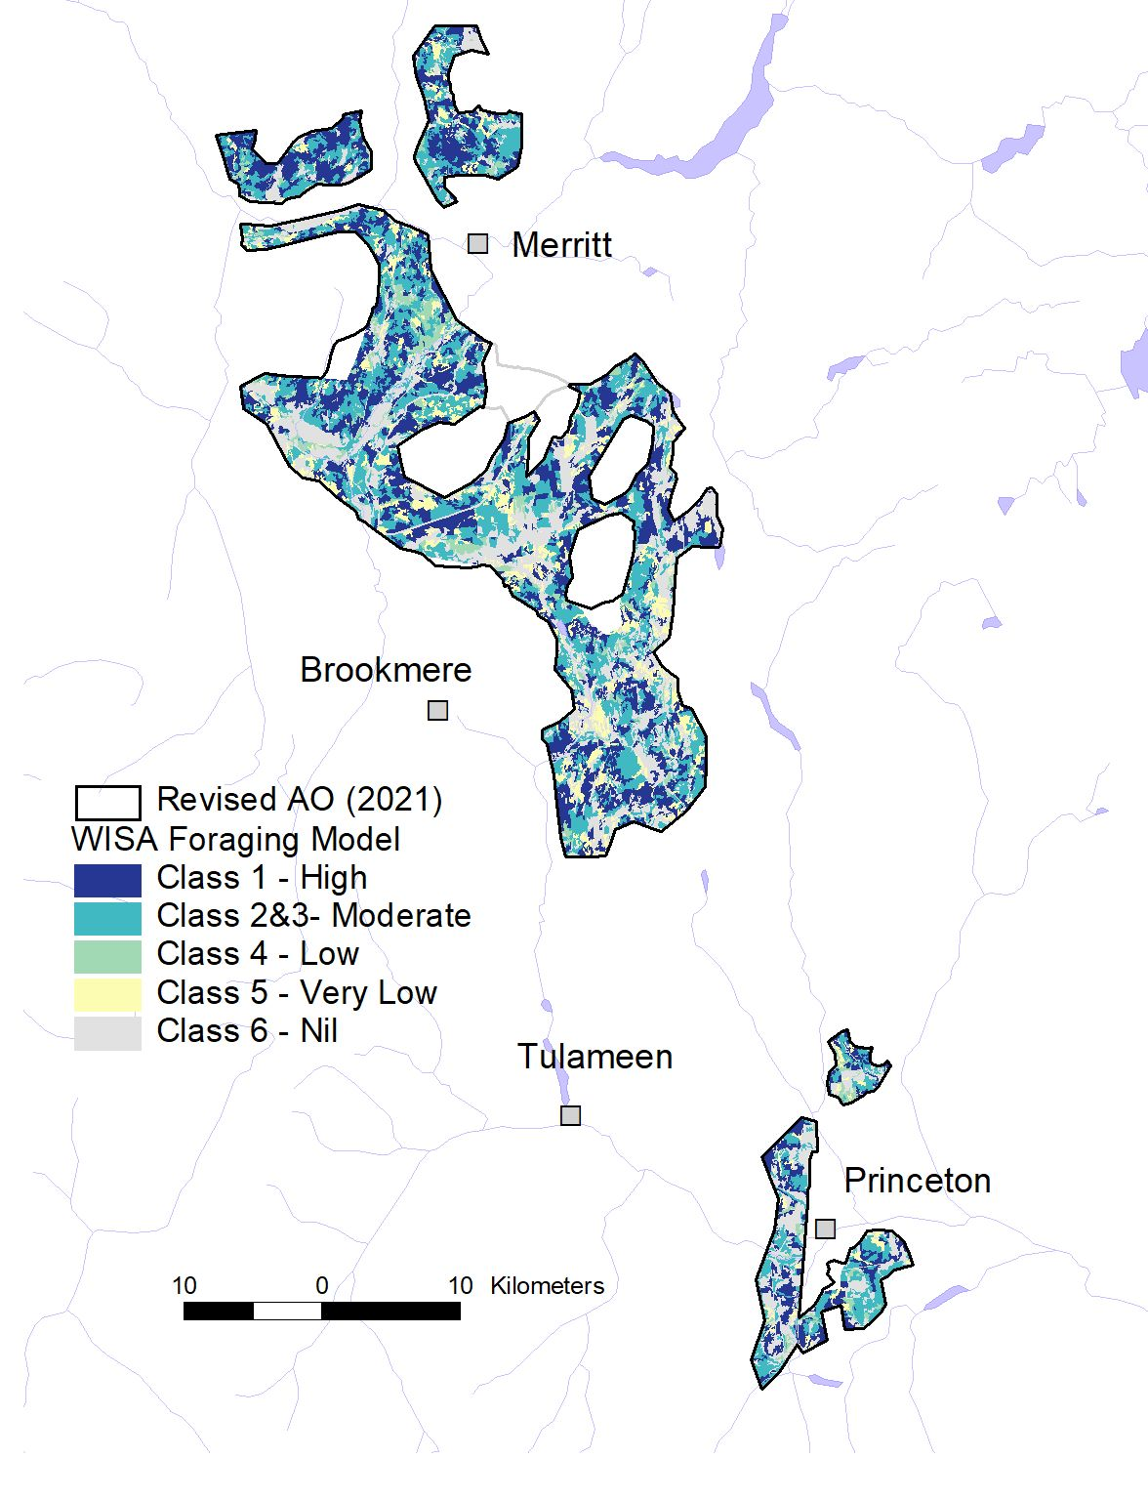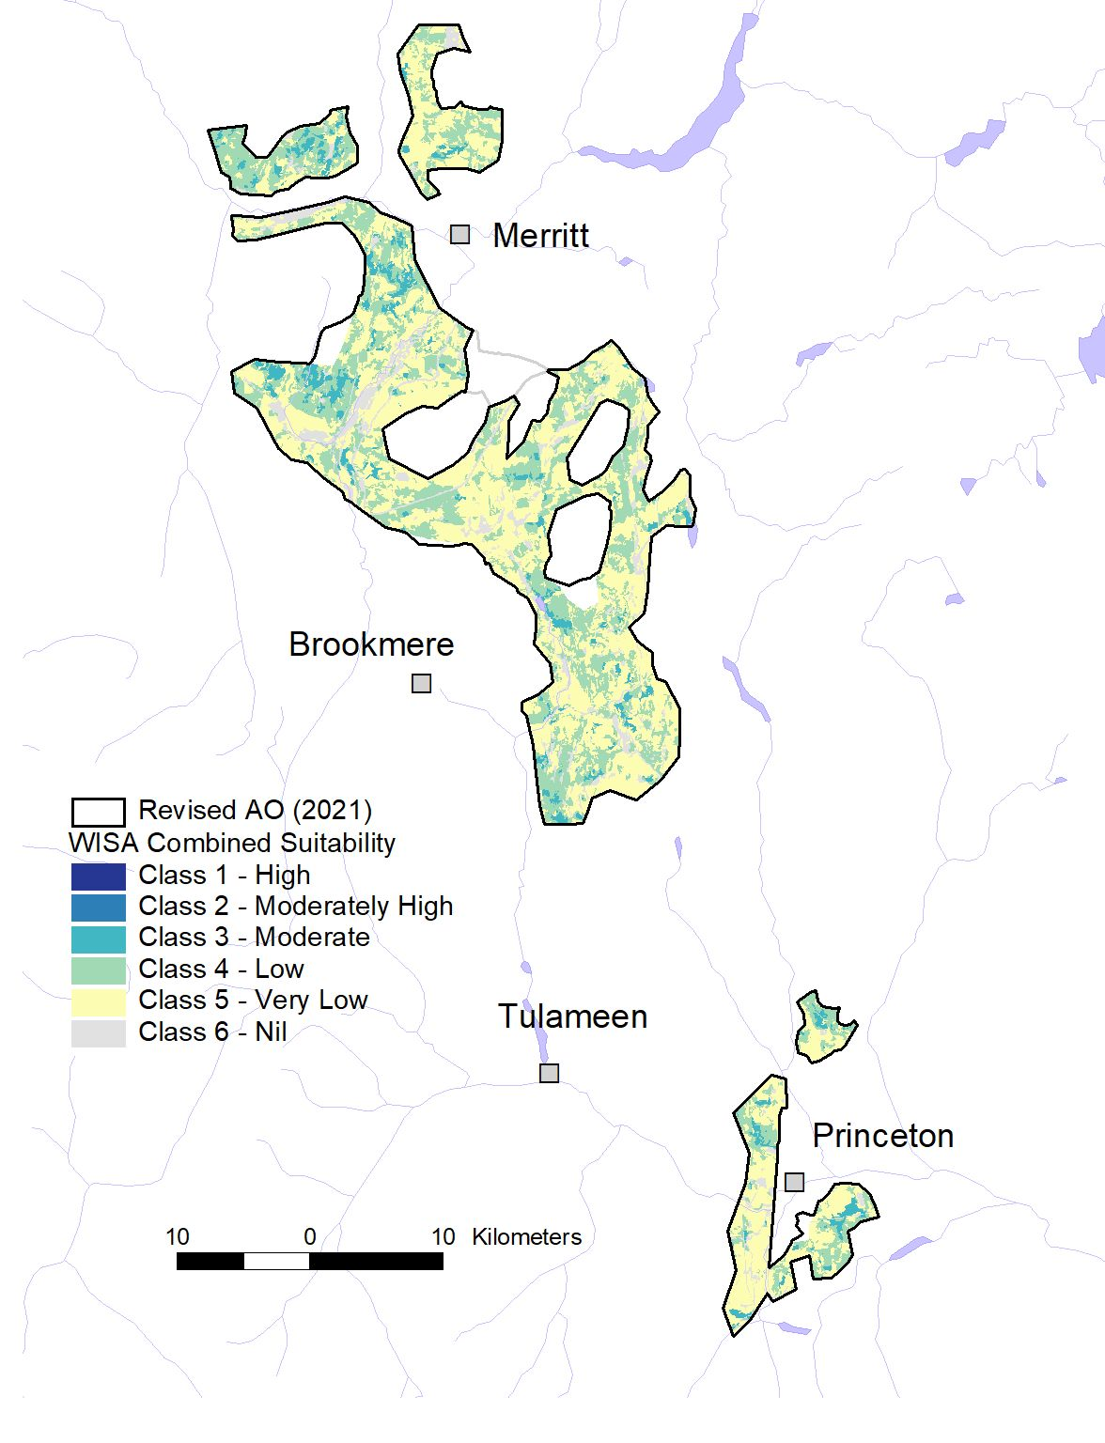
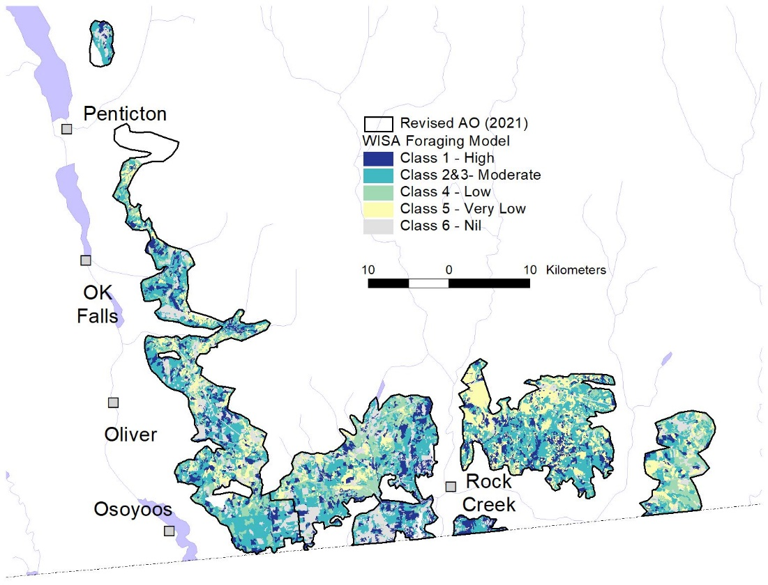
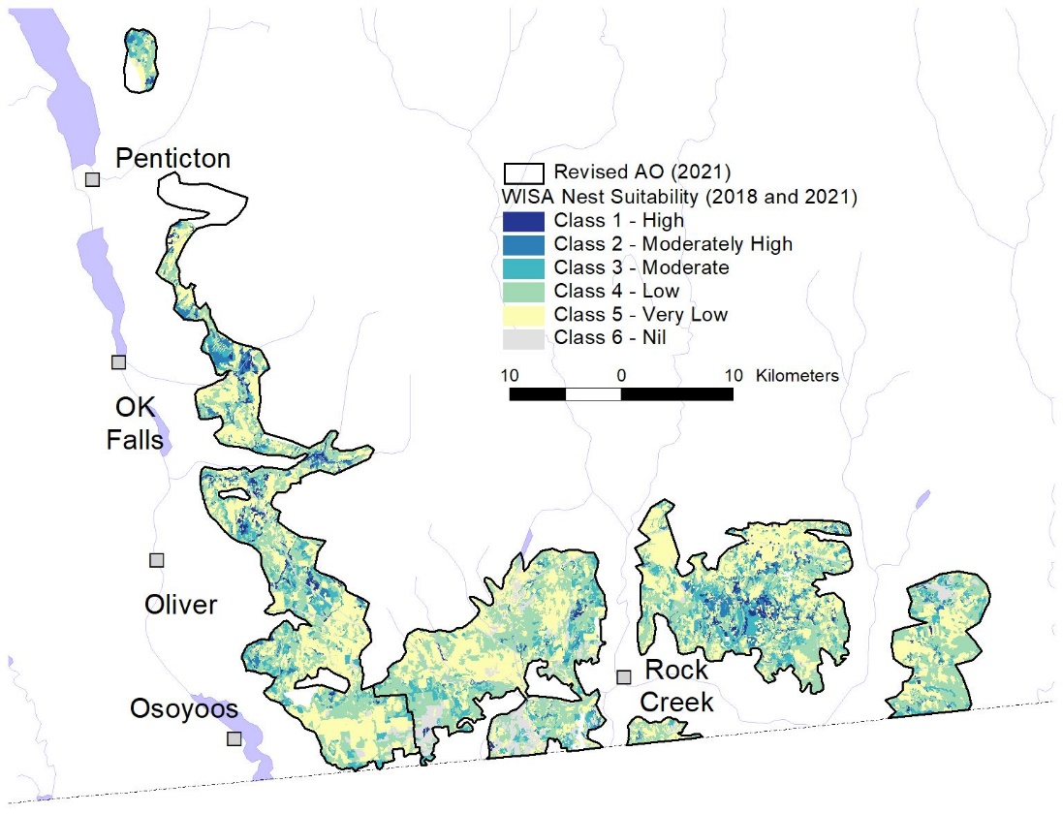
Map 5. Williamson's Sapsucker 2018-2021 habitat suitability model updates Okanagan-Boundary region. Blank spots within AO have not been updated with habitat mapping after 2021 AO revisions.
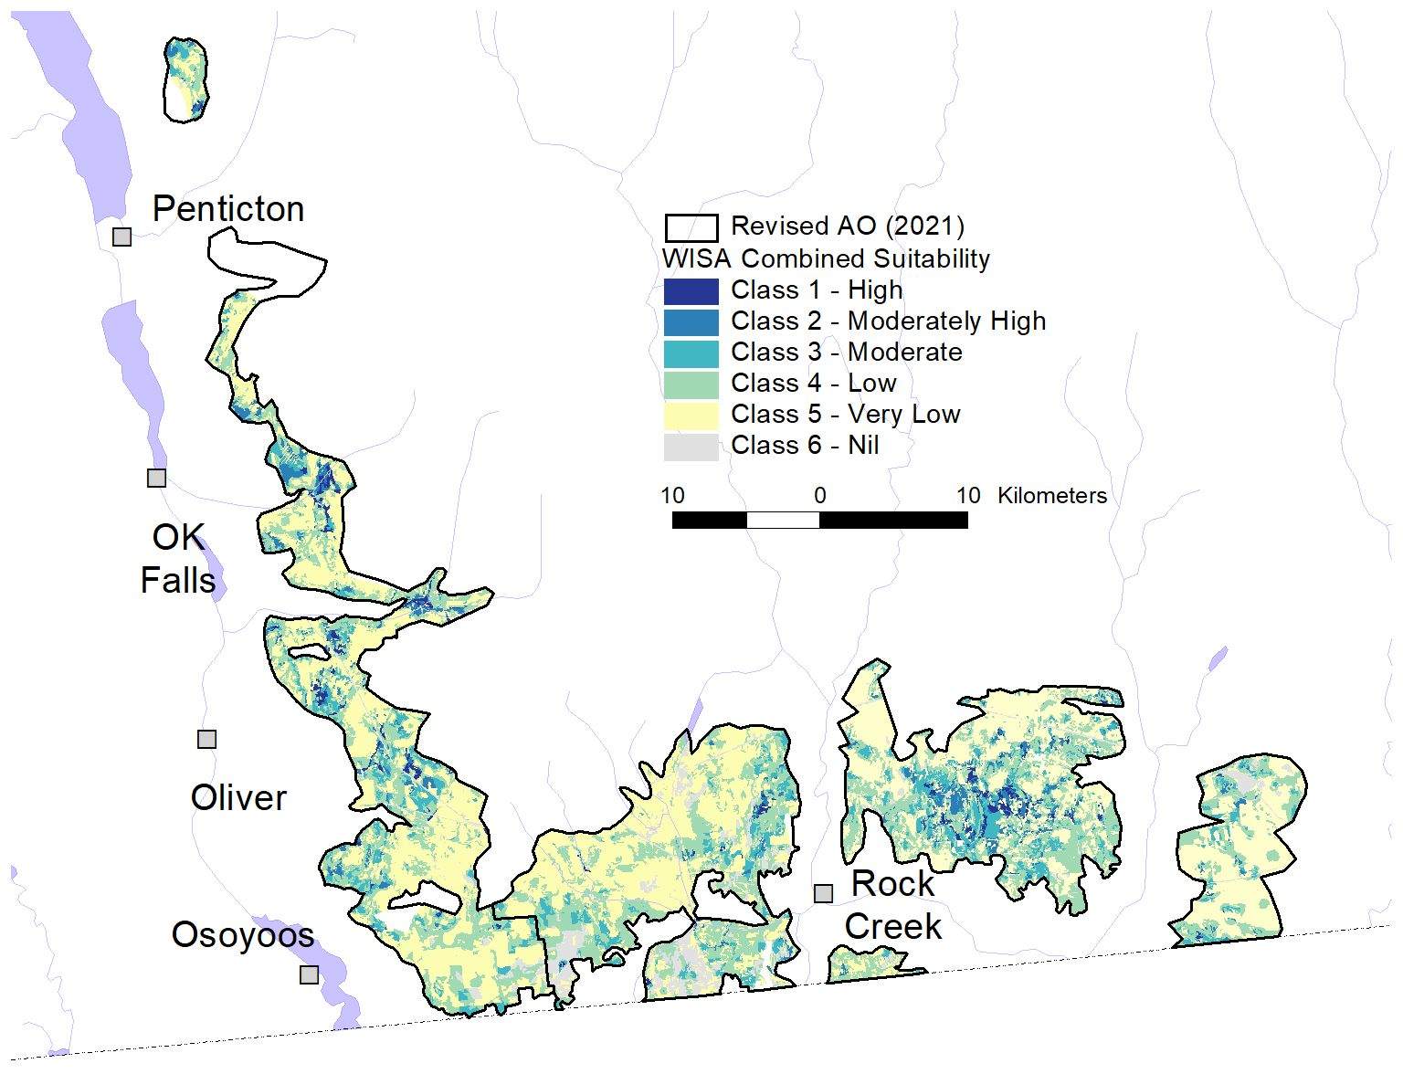

Data Products
wisa_ao_2020 – Polygon shapefile, BC Albers projection, of updated WISA Area of Occupancy based on additional WISA detections up to the end of 2020 as outlined in this report.
wisa_vri_suit_combined_2021-03-05a – Polygon shapefile from VRI polygon base 01/01/2016 adjusted with boundary and attribute changes to January-March 2018. This shapefile contains VRI fields, modeling adjustment fields based on photo review, WISA key factor and adjustment fields, and the final 2018 suitability rating.
wisa_vri_combined_suitability_2020-07-24b – shapefile set, BC Albers projection, for 2018 habitat update with foraging added to nest model. Covers West, Okanagan, and the 2018 part of Boundary (see Gyug and St-Amand 2020). The error found in Step 15 interpretation in 2020 has been corrected in this “b” version.
Each of these has shapefile sets has been put into a zip file for storage on the WISA ftp site, with total size of all three <10 MB.

References
COSEWIC. 2005. Status Report on Williamson's Sapsucker, Sphyrapicus thyroideus. Committee on the Status of Endangered Wildlife in Canada, Canadian Wildlife Service, Ottawa.
COSEWIC. 2017. COSEWIC assessment and status report on the Williamson's Sapsucker, Sphyrapicus thyroideus in Canada. Committee on the Status of Endangered Wildlife in Canada, Ottawa.
Gyug, L.W. 2009. Final species account for species-habitat model for Williamson’s Sapsucker in the Boundary. Report prepared for BC Timber Sales, Kootenay Business Region, Nelson, BC.
Gyug, L.W. 2014. Williamson's Sapsucker monitoring 2014: Okanagan, Boundary and West. Report prepared for Environment Canada-Canadian Wildlife Service, Delta, B.C.
Gyug, L.W. 2010a. Final species account for species-habitat model for Williamson’s Sapsucker West of Okanagan Lake. Report prepared for Environment Canada, Canadian Wildlife Service, Delta, B.C., and Ministry of Environment, Victoria, B.C.
Gyug, L.W. 2010b. Final species account for species-habitat model for WISA in the Okanagan. Report prepared for Weyerhaeuser Co. Ltd., Princeton, B.C.
Gyug, L.W. 2010c. Williamson's Sapsucker Final species account for species-habitat model for the East Kootenay. Report prepared for Ministry of Forests, Lands, Natural Resource Operations, Victoria, B.C., and for Environment Canada-Canadian Wildlife Service, Delta B.C.
Gyug, L.W. 2018. Species account for Williamson's Sapsucker nest habitat model, Okanagan-Boundary and West regions, British Columbia. Report prepared for Ministry of Forests, Lands, Natural Resource Operations and Rural Development, Kamloops, B.C.
Gyug, L.W. and J. St-Amand. 2020. Species account for Williamson's Sapsucker habitat models 2020. Report prepared for Okanagan Nation Alliance, Westbank, B.C.
IUCN. 2001. IUCN Red List categories and criteria: Version 3.1. Prepared by IUCN Species Survival Commission. World Conservation Union, Gland, Switzerland and Cambridge, United Kingdom. https://help.natureserve.org/biotics/Content/Record_Management/Element_Files/Element_Ranking/ERANK_Definitions_of_Extent_of_Occurrence_and_Area_of_Occupancy.htm
NatureServe Explorer. 2021. Sphyrapicus thyroideus Williamson's Sapsucker https://explorer.natureserve.org/Taxon/ELEMENT_GLOBAL.2.101135/Sphyrapicus_thyroideus
Resources Inventory Standards Committee (RISC). 1999. BC Wildlife Habitat Ratings Standards Version 2.0. Ministry of Environment, Lands and Parks, Victoria, B.C.
St-Amand, J. 2017. Foraging ecology of endangered Williamson's Sapsuckers in Canada: multi-scale habitat selection in two biogeoclimatic zones. M.Sc. Thesis, University of British Columbia, Vancouver, B.C.
Wang, T., A. Hamann, D.L. Spittlehouse, and T.Q. Murdock. 2012. ClimateWNA – High-resolution spatial climate data for western North America. Journal of Applied Meteorology and Climatology 51:16-29.
Wang, T., A. Hamann, D. Spittlehouse, and C. Carroll. 2016. Locally Downscaled and Spatially Customizable Climate Data for Historical and Future Periods for North America. PLoS ONE 11(6): e0156720. doi:10.1371/journal.pone.0156720.

Appendix 1. Williamson's Sapsucker Habitat Modeling Methods
This is divided into three sections. In the first section are outlined the steps to make the VRI suitable for WISA habitat modeling. In the second section are the steps to apply the habitat models to the VRI once it has been made suitable for modeling. The third section outlines the steps to apply the foraging model, and combine it with the nest habitat model.

Section 1: Making VRI suitable for WISA habitat modeling.
Base was the VRI geodatabase in BC Albers projection projected to January 1, 2020, which became available in February 2021.
- The polygons of interest intersecting the WISA AO were selected by location and saved as a shapefile.
- For Boundary 2021, no attempt was made to fix VRI sliver gaps between TFL 8 and other crown or private lands. These were left without any habitat modeling, as were NTA (No Typing Available) polygons (n = 2).
- All VRI tree layers were required, not just Rank 1. The polygon shapefile contained the polygon info but no tree species info. The tree species info was in a separate gdb table.
- The records from the tree species gdb tables were matched using Feature ID of the polygon shapefile. Those records were selected and saved as separate tables for each of four tree layers and the dead layer.
- I determined how many layers each polygon had, and which layer was Rank 1 (the highest volume layer). I manipulated the .txt file to make a separate .txt file for each layer including:
  - Rank 1 layer, and
  - then for any polygons that had separate Layers 1, 2, 3, 4 and Dead.
- If there was only one layer for a polygon, it was the Rank 1 layer. Non-forest polygons did not have any tree layer information to attach.
- To be able to attach the .txt file with the layers to the shapefile, I renamed the field headings to 10 characters so that they can be used in the dbf file created when attached to the shapefile. These were only attached in a later step.
- For the Boundary update 2020, elevation was not a factor within AO, but slope was. Therefore a new slope layer was developed (<30%, >30% slopes) from a 25-m DEM.
- The VRI shapefile was unioned with the Slope shapefile. Any resulting sliver and small polygons of <0.1 ha were dissolved into their original VRI polygons.
- The VRI polygons were clipped to the WISA contiguous AO shapefile in the project area.
- Where intersections of polygons or clipping to the AO boundary created sliver or tiny polygons of <0.1 ha, these were dissolved into their original VRI polygons, or adjacent polygons if not adjacent to their original VRI polygon.
- The forest layer tables (L1R0 (the layer that was taller than the R1 layer), R1, L2, L3, L4, Dead) were attached to the altered VRI polygon layer.
- For Boundary 2020, the VRI layer was used as presented, i.e., no updates to polygons based on any cuts or burns more recent than contained in the January 1, 2020 VRI layer. Therefore, the Boundary mapping will not be completely up-to-date to 2021, and is really only up-to-date to about early 2018, making it compatible with the habitat updates done for the other areas in March 2018.
- VRI no longer uses the Non-Forest descriptors used in the old Forest Cover Mapping (e.g. L for Lake, OR for Open Range). These codes were used in the 2008 WISA modeling. Where newly interpreted VRI had blanks for these codes in non-forest polygons, I interpreted what the code would have been so that some areas (truly non-treed) could be assigned Unsuitable, and that potentially treed SWAMP or OR could be identified. Most of these assessments were already done in 2008, and the 2008 polygon attributes copied into the new VRI.
- I had made many adjustments to the VRI attributes and polygons in 2008 where forest attributes or species were actually present based on colour stereo aerial photo examination but were not present in the VRI. Examples were veteran trees, At presence, trees within Open Range polygons, and retained ST or more dense tree retention within “clearcuts”. These were rejoined manually polygon by polygon where possible. The 2020 VRI base used were almost entirely the same polygons used in the 2008 original habitat mapping, so many or the manually adjusted attributes could simply be copied over.
- New fields were created to hold attributes used in the WISA habitat modeling. These included Maximum Age of any layer within a polygon, maximum R1 age and height (since each polygon and within each layer may have two ages or heights), presence of Fd, Lw, Py, At, Ew/Ep, Cw, Pl, Bl, and the percent cover of each in R1 layer.
- Checking of private lands and clearcuts, seedtree cuts or partial cuts for actual tree densities or presence of vets was not done in 2021, nor splitting of VRI polygons with cuts more recent than the VRI. Consequently, this update is not completely up-to-date, and is optimistic where such lands have been recently completely or partially cleared or the timber harvested.

Section 2: Applying the WISA habitat modeling to the adjusted VRI.
Okanagan-Boundary
Sequential Criteria for Keys. Each Key Factor has its own field in the Excel file named file sequentially as “KeyFctr_01”, “KeyFctr_02” etc. as per the bullets below.
The coded values assigned are in brackets. If no criteria fit, then coded value was set to 0 (default).
- NP Codes, all but OR, R, S, NSR, NP, NPBU, NPBR (1) (or 9 for No Typing Available – not mapped)
- NP Codes OR, R, S (1)
- R1 Age >190 (1), >120 (2)
- R1 Ht >29.0 (1)
- SI of any layer >15.0 (1)
- R1 CC >30% (1), >20% (2)
- CC >15 m ht >20% (1)
- Age of oldest Layer >190 (1), >125 (2), >80 (3)
- Fd/Lw (assigned codes in order from a to b)
  - Fd or Lw leading, Fd and Lw present (1),
  - Fd or Lw present (2),
- Cw <10% (1)
- Sum Pl + Bl <30% (1), <60% (2)
- Sum Fd and Lw% of R1 >40% (1)
- % Fd of all layers >14.9 m ht 10-90% (1), Fd 91-99% (2)
- Sum of Fd+Lw % >40% of either R1, L2, or just present in L1R0 (1)
Assign First Stage Suitability if not already 5 or 6 (Keys 1 and 2). These Assignments are listed in the Excel file as fields FSuit156, First_Suit3, etc.
FSuit156: Suit 6 if 1 =1, Suit 5 if 2 =1, and Suit 1 if 3, 4, 5, 9, 10, 11 all=1, and for Bdy, 13 = 1
FirstSuit2 = 2 if 3 = 1, 6 = 2, 8 = 1, 9 = 1, 10 = 1, 11 = 1, and for Bdy 13 = 1
FirstSuit3 =3 if 3 = 1 or 2, 7 =1, 8 = 1 or 2, 9 = 1 or 2, 10 = 1, 11 = 1, and for Bdy 13 =1
FirstSuit4 =4 if 8 =1, 2, or 3, 9 = 1, 2 or 3, 10 =1, 11 = 1 or 2, 12 = 1, for Bdy 13 = 1 or 2, for Okanagan 14 = 1.
First_Suit = whichever of the above first applies, and Suit 5 for any polygons not yet classified
Second Stage Suitability
15. Slope >30%, and Suit 1, reduce to 2, if Suit 2 or 3, reduce to 4 (In 2018, I only reduced Suit 2 by 1 level to Suit 3, but which should have been to Suit 4 to be consistent with 2008 modeling. This was the error corrected from 2018, and the correction noted here re-applied to the Okanagan and other Boundary areas of 2018 to make them all consistent, and consistent with 2008).
Third Stage Suitability Adjustments were done individually for each polygon as per numbered bullets in lower half of summary table on next page. These included fields corrected from 2008 (field CORREC2009 as adjusted from stereo aerial photos) and NEWFCINFO (new adjustments from orthos, satellites and attributes). Steps used in prior years, but not used in 2021 were deleted from the table.

Limitations
Some stands have aged in the past 10 years above the age criteria (i.e., 190 years, 125 years, 120 years or 80 years), without actually changing much in suitability in terms of availability of nest sites. Over time, re-assessment of actual nest sites vs current stand age will be required, but this has not yet been done.
An assumption of this classification is that likely nesting trees (primarily veteran Lw) are more common and abundant in older forests (>80 years old, in particular). Most of these nest Lw trees were veteran trees generally >300 years old, i.e., much older than the other trees in the stand in which they occurred, although the VRI database tends to be rather conservative in estimating age of these veteran trees. In the Boundary AO, most older stands will contain these trees as the stands are the product of a mixed fire regime, and of much high-grading or partial cutting from about 1900-1970 and were therefore not even-aged. In areas where most stands are even-aged, this classification will not correctly classify habitat, because the assumption that veteran Lw occur in most stands >80 years old will not be correct. For example, the extensive even-aged stands generated by the 1931 Camp McKinney fire will not somehow transform into WISA habitat when they become >80 years old unless these stands have already been noted as containing veteran Lw during the aerial photo correction mapping phase.

Summary of WISA Nest Habitat Suitability for Okanagan-Boundary contiguous AO used in 2021.
Factors used in other years, but not considered in 2021 were removed from this table.
Input Variables |  | High (H) (1) |  | Moderately High (M) (2) |  | Moderate (M) (3) |  | Low (L) (4) |  | Very Low (5) |  | Nil (6)
Rank 1 Layer Projected Age |  | >190 years |  | >190 years |  | >120 |  |  |  | Any other forested, potentially forested or non-productive polygons;  OR, Rock and Swamp polygons as per adjustments below |  | All other non-forest polygons
Rank 1 Layer Projected Ht |  | >29.0 m |  |  |  |  |  |  |  |  |  | All other non-forest polygons
Rank 1 Layer Site Index |  | >15.0 |  |  |  |  |  |  |  |  |  | All other non-forest polygons
Rank 1 Layer Crown Closure |  | >30% |  | >20% |  |  |  |  |  |  |  | All other non-forest polygons
Crown Closure ≥15.0 m ht |  |  |  |  |  | >20% |  |  |  |  |  | All other non-forest polygons
Age of oldest layer |  | >190 years |  | >190 years |  | >125 years |  | >80 years |  |  |  | All other non-forest polygons
Tree Species |  | Fd or Lw leading, contains Fd and Lw |  | Fd or Lw leading, contains Lw |  | Fd or Lw present |  | Fd or Lw present |  |  |  | All other non-forest polygons
Cw %. |  | <10% |  | <10% |  | <10% |  | <10% |  |  |  | All other non-forest polygons
Sum of Pl and Bl % |  | <30% |  | <30% |  | <30% |  | <60% |  |  |  | All other non-forest polygons
Sum of Fd and Lw % |  |  |  |  |  |  |  | >40% |  |  |  | All other non-forest polygons
Boundary: % Fd of all layers ≥15.0 m ht |  | 10-90 |  | 10-90 |  | 10-90 |  | Fd <100% |  |  |  | All other non-forest polygons
Okanagan: Sum of Fd and Lw % of either L1 or L2 , or just present in L1R0 (veteran) layer |  |  |  |  |  |  |  | >40% |  |  |  | All other non-forest polygons
Adjustments:
Reduce 1 level if | Slope >30% |  |  |  |  |  |  |  | Do not reduce
Upgrade from VL to L if | - Forested polygon (>10% Crn Clos ≥15 m ht) and Lw present at >1/ha and Lw age >125 yr
 | - Forested polygon (>10% Crn Clos ≥15 m ht) contains Fd or Lw, contains At >4% of stand, age >55 yr, and Pl <55% of stand
 | - NP but age>125, on south or gentle slope, contains Lw, Crn Clos >10%
Upgrade from VL to L if slope <30% and | - Mature At patches >1 ha and adjacent to Fd/Lw forest, i.e., not Pl/Se
 | - Fire-origin (60-100 yr), old high-graded stands, or old light partially cut stands (1960s-1980s) if:
 | - Lw vets scattered throughout at >0.5/ha, or
 | - Upgrade the portions of the stand with clumps of vets
 | - if Ep/Ew and Lw occur in Layer 1, stand is not NP, slope <30%, Crown closure >25% and >10 m tall, and >50 years old
 | - Any other forested stands containing vets >0.5/ha but that had been assigned VL

Section 3: Application of Foraging Model to Nest Habitat model

The process for modeling foraging habitat and combining with the nest habitat model was derived and explained in Gyug and St-Amand (2020). Here I only repeat the final methods, and not the derivation. The foraging model is an equation with a score derived using tree density and its square as the only factors (see Gyug and St-Amand 2020). This score was converted to a foraging suitability rating according to the following table.
Foraging Habitat Suitability ratings by selection score from model based on VRI Density of stems/ha >17.5-cm dbh and on distribution of WISA detections by density.
Rating Class | % of WISA detections | VRI Tree Density Range | Foraging Selection Score values | As applied to Combined Model
Okanagan-Boundary
High (1) | 76-100 | 291-386 | >1.250 | Useful habitat
Moderate (2 & 3) | 26-75 | 121-290, 387-555 | 1.075 – 1.250 | Useful habitat
Low (4) | 6-25 | 10-120, 556-741 | 0.625 – 1.074 | Not as useful
Very Low (5) | 1-5 | 1-9, >741 | <0.625 | Not useful habitat
Nil (6) | 0 | Zero | Non-forest (0.813) | Not useful habitat
West
High (1) | 76-100 | 182-325 | >1.700 | Useful habitat
Moderate (2 & 3) | 26-75 | 77-181, 326-427 | 1.111 – 1.700 | Useful habitat
Low (4) | 6-25 | 27-76, 428-479 | 0.630 – 1.110 | Not as useful
Very Low (5) | 1-5 | 1-26, >479 | <0.630 | Not useful habitat
Nil (6) | 0 | Zero | Non-forest (0.335) | Not useful habitat

The Nest habitat model shapefile made of adjusted or intact VRI polygons was converted to a grid with pixel size of 5 m (20 m was used in 2020, but 5 m grid could be rebuilt into polygons more accurately for the limited 2021 project area). The foraging model was only used to adjust the nesting model by downgrading the nesting suitability where foraging suitability was insufficient (on average) to support successful breeding territories as per the ratings. Since the nesting model already considered tree species presence and/or percentage, the foraging model based only on density was not hampered by its simplicity.
However, different for the Boundary 2020, polygons with no Fd or Lw were not considered to be suitable for foraging and assigned Very Low rating. In addition, stand height was included as a factor because regenerating even-aged stands <15-m maximum ht sometimes had a few trees peaking up into the 17.5 range, producing a density and thus a foraging score as if they were older stands (see data points of QMD~20 and densities of 75 -400 stems/ha >17.5-cm dbh on Figure 9 of Gyug 2020). These regenerating stands are not well captured in the density regression equation, which was mainly based on old high-graded stands rather than even-aged stands, which are generally not suitable foraging sites having very high overall tree densities but with most of them just under 17.5-cm dbh. These stands with no Crown Closure >15 m ht were assigned Very Low foraging suitability.
Algorithms for combining the nest model and foraging model were done at three scales: 80 m, 340 m (mean 95% nest territory radius) and 460-m (radius of mean 95% nest territory area + 1 SD by area) as follows:
- For open sites, e.g., sites with no VRI forest layers, e.g. such as clearcuts, seed tree cuts and open range, the 80-m scale (mean nest distance from forest where <50 trees/ha plus 1 SD) was used to adjust individual pixels as follows:
  - All such sites had been modeled in 2008-2018 as maximum Low nesting suitability, although most may be Very Low.
  - In the combined model, Low suitability pixels were only retained as Low if within 80 m of foraging habitat.
  - Low nesting suitability adjusted down to Very Low combined suitability if >80 m from High, Moderate or Low foraging habitat if VRI tree density <100/ha.
  - Using moving average, the 80-m radius around any given Low pixel of low (or zero as mapped in VRI) tree density must have at least 1 pixel of High, Moderate or Low foraging suitability in the 80-m neighbourhood to retain its Low suitability.
  - This 80-m radius was of limited use in the 2020 Boundary project, where Open Range polygons had been rolled over from original FC designation, i.e., no tree layers had been mapped, so OR would be considered unsuitable for foraging. More recent VRI interpretations do map some tree layers within Open Range. In addition, I had not done individual Open Range and block/polygon estimates of tree density either existing naturally or left after timber harvesting based on orthophotos, so did not differentiate reliably between no tree, 1-100 trees/ha and denser stands.
- For any site with Low or better nest habitat suitability, the 340 m scale was used to reduce individual pixels of any nesting suitability if adequate High and Moderate suitability foraging habitat was unavailable.
  - Using moving average, the 340-m radius around any given pixel must have ≥19.5 ha (53% of 340-m radius circle) High or Moderate foraging suitability (0.53 as mean of 340-m circular neighbourhood analysis).
  - High, Moderate and Low nesting suitability pixels reduced in combined suitability if <45% High and Moderate foraging suitability available within 340 m by
    - 2 levels for High and Moderately High,
    - 1 level for Moderate and Low,
- Any site reduced in step 2, was reconsidered at the 460-m scale.
  - If the 460-m neighbourhood around a pixel contained ≥19.5 ha High or Moderate foraging suitability (i.e., 0.29 as mean of 460-m circular neighbourhood analysis),
    - then the rating, if reduced in Step 2 to Very Low, was re-raised to Low.
  - If the 460-m neighbourhood around a pixel contained <19.5 ha High or Moderate foraging suitability (i.e., 0.29 as mean of 460-m circular neighbourhood analysis),
    - then the rating, if reduced in Step 2 to Moderate or Low, will be further reduced by 1 rating level (Moderate to Low; Low to Very Low).
- Otherwise, no change.
- The grid made of the combination of polygon ID from the suitability shapefile, and the 3 grid results (either 0 or 1) of Steps 1, 2 and 3 was converted back to a shapefile, and the VRI and other attributes from the suitability shapefile reconnected based on the ID field. Each polygon was then assigned a new sequential ID, keeping the old ID for reference (and re-joining if necessary). At this point, any polygons ≤125 m² were dissolved into their parent polygons from the suitability shapefile. If the parent polygon was no longer adjacent, then were dissolved into polygon with longest border. Then any polygons <0.1 ha (1000 m²) were dissolved into their parent polygons if they shared a border. The grids were not kept as they were only a temporary step.

